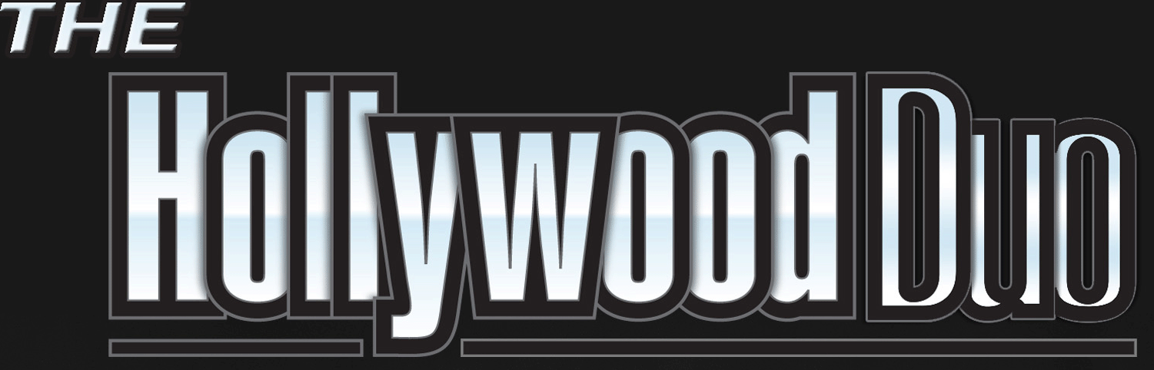Master Song List

Current/Recent Pop

Cake By The Ocean-DNCE

Can'T STOP THE FEELIN'- Justin Timberlake
FEEL MY FACE-The Weeknd
GET LUCKY-Daft Punk
HEAT WAVES-Glass Animals
BAD HABITS-Ed Sheeran
MEMORIES-Maroon5

MOVES LIKE JAGGER-Maroon5
PERFECT-Ed Sheeran

SAY YOU WON'T LET GO- James Arthur
SHAPE OF YOU- Ed Sheeran

SHUT UP AND DANCE-Walk The Moon

SUCKER - The Jonas Brothers

THINKIN' OUTLOUD-Ed Sheeran

WANT TO WANT ME-Jason Derulo
I WILL WAIT-Mumford & Sons
HO! HEY!-Lumineers
WAKE ME UP-Avici

Classic Dance
FOOTLOOSE-Loggins & Mecina

I Want You To Want Me-Cheap Trick
My Girl-The Temptations

play that Funky music-Wild Cherry
ROCK YOUR BODY- Justin Timberlake
Stand by me-Ben E. King
STAYIN' ALIVE-The Bee Gee's
sweet caroline-Neil Diamond
Wonderful Tonight-Eric Clapton

80’s
867-5309/Jenny-Tommy Tu-Tone
Billie Jean-Michael Jackson
DON’T STOP BELIEVIN’-Journey
Jessies girl-Rick Springfield
Little Red Corvette-Prince
Pour Some Sugar On me-Def Lepard
PURPLE RAIN-Prince
Summer of ’69-Brian Adams

Classic rock
ANY WAY YOU WANT IT-Journey
BACK IN BLACK-Ac/Dc
BLACK BETTY-Ram Jam
Blister in the Sun-Violent Femmes

HERE I GO AGAIN-Whitesnake
HURTS SO GOOD-John Cougar
I Love rock & roll-Joan Jett
JOKER-Steve Miller
Keep Your Hands to Yourself-Georgia Satellites
LIFE IN THE FAST LANE-Eagles
LIVIN ON A PRAYER-Bon Jovi
SWEET CHILD O’ MINE- Guns N’ Roses
sweet emotion-Aerosmith
Sweet Home Alabama-Lenard Skynard
TAKE IT EASY-Eagles
WHOLE LOTTA LOVE-Led Zepplin
YOU SHOOK ME (ALL NIGHT LONG)- Ac/Dc

Country
CHICKEN FRIED-Zack Brown Band
CRUISE-Florida Georgia Line/Nelly
Friends in low Places-Garth Brooks
S.O.B-Nathaniel Rateliff

SAVE A HORSE, RIDE A COWBOY-Big and Rich
TENNESSEE WHISKEY-Chris Stapleton
TEQUILA-Dan + Shay
WAGON WHEEL-Darius Rucker

90's-2000’s Pop/Alternative

​3am- Matchbox 20
AMERICAN GIRL-Tom Petty
ANTS MARCHING-Dave Mathews Band

breakfast at Tiffany’s- Deep Blue Somthing
CLOSING TIME-Semisonic
DANI CALIFORNIA-Red Hot Chili Peppers

drops of Jupiter-Train

Flagpole sitta- Harvey Danger
GIVES YOU HELL-All American Rejects
GOLD ON THE CEILIN’-The Black Keys
LAST DANCE W/ MARY JANE-Tom Petty

Mr. Brightside- The Killers

Mr. JONES- Counting Crow’s
OWN WORST ENEMY-Lit
SANTARIA-Sublime

Save Tonight- Eagle Eye Cherry
SAY IT AINT SO-Weezer

sex on fire-Kings of Leon

SEMI-CHARMED LIFE-Third Eye Blind
SHE-Green day

Slide-Goo-Goo Dolls

Somebody told me- The Killers

THE MIDDLE-Jimmy Eat World
TWO PRINCES-Spin Doctors

What I Got-Sublime

